**Assignment Day 4**

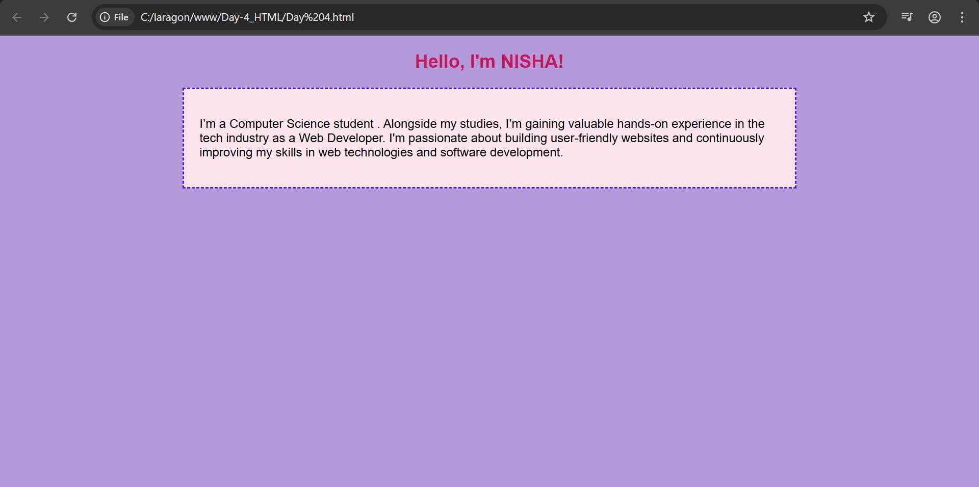

In this webpage, I created a simple personal profile using HTML and CSS. I styled the page background with a soft color and customized the text using internal CSS for fonts and colors. The profile heading includes inline styling, and the main bio section is styled with a dashed border, padding, and background color to make it visually appealing. I also linked an external CSS file, fulfilling the use of all three CSS methods—inline, internal, and external.